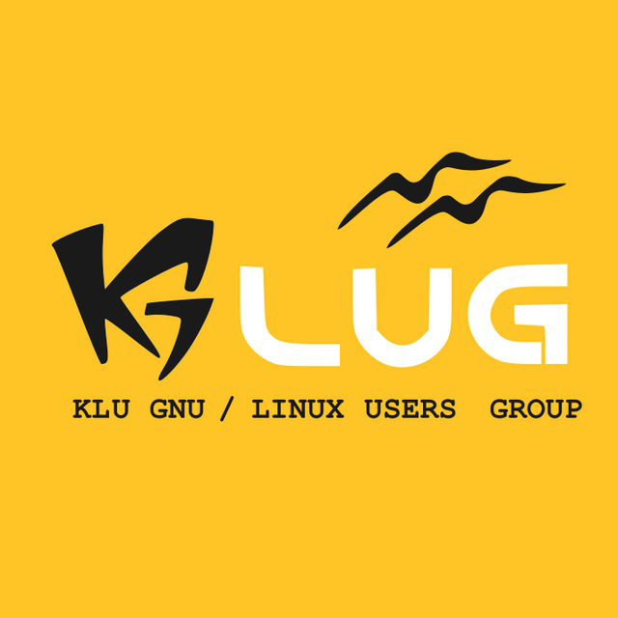

KLU GLUG MEET ON 09-08-2017

Session on Elixir-1:

Elixir is a dynamic, functional language designed for building scalable and maintainable applications. Elixir leverages the Erlang VM, known for running low-latency, distributed and fault-tolerant systems, while also being successfully used in web development and the embedded software domain.

Session by:- B Nikhil Prabat

Students Attended:-
57 students attended the session on Elixir.

Classroom/Venue:- C108

